Lab7A: Configuring QoS on Cisco Routers
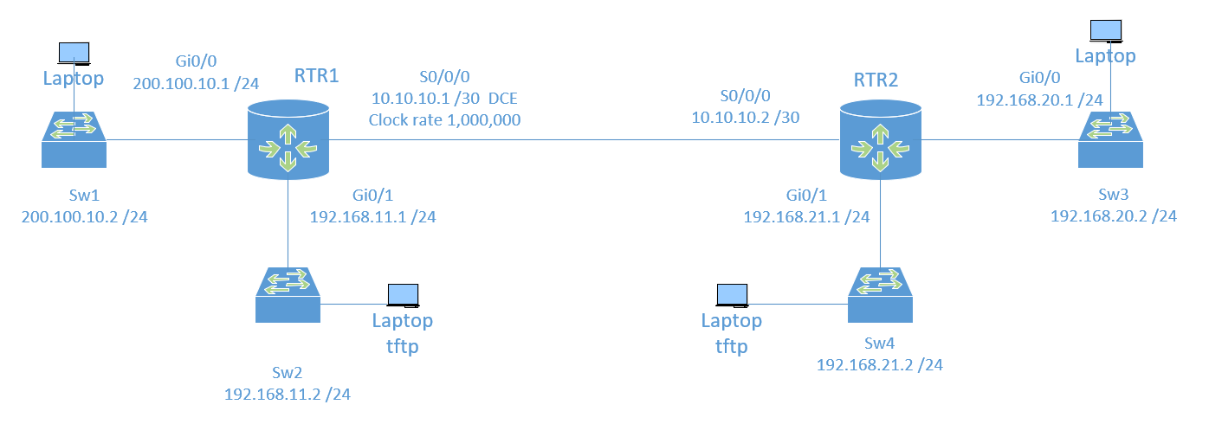
Objectives:
1. Create and apply QoS policies on Cisco routers.
2. Shape and police traffic across a WAN link.
3. Ensure preferential treatment for specific traffic types.

Topology:
RTR1 Configuration:
Int G0/0 = 200.100.10.1 /24
Int G0/1 = 192.168.11.1 /24
Int S0/0/0 = 10.10.10.1 /30 (512 kbps HDLC WAN link, DCE)

RTR2 Configuration:
Int G0/0 = 192.168.20.1 /24
Int G0/1 = 192.168.21.1 /24
Int S0/0/0 = 10.10.10.2 /30 (512 kbps HDLC WAN link)

Step 1: Configure Basic Settings
RTR1 Configuration:
enable
configure terminal
hostname RTR1
interface g0/0
ip address 200.100.10.1 255.255.255.0
no shutdown
exit
interface g0/1
ip address 192.168.11.1 255.255.255.0
no shutdown
exit
interface s0/0/0
ip address 10.10.10.1 255.255.255.252
clock rate 1000000
no shutdown
exit
ip route 0.0.0.0 0.0.0.0 10.10.10.2

RTR2 Configuration:
enable
configure terminal
hostname RTR2
interface g0/0
ip address 192.168.20.1 255.255.255.0
no shutdown
exit
interface g0/1
ip address 192.168.21.1 255.255.255.0
no shutdown
exit
interface s0/0/0
ip address 10.10.10.2 255.255.255.252
no shutdown
exit
ip route 0.0.0.0 0.0.0.0 10.10.10.1

Some traffic notes or wishes:
Important Data is traffic moving between 200.100.10.0 and 192.168.20.0 networks. I want this treated with some higher importance.
Bulk Data is just regular traffic that is moving between the 192.168.11.0 and 192.168.21.0 networks. I don’t need to be crazy strict with this traffic, but I would like some QOS applied.
TFTP traffic – this should be limited to some amount of bandwidth when things get busy.
Telnet traffic – for this lab, I want this given preference over other traffic. This would never be done in the real world.

Step 2: Define Class Maps
RTR1 and RTR2 Configurations (pay attention to which you are, as the ACLs will be mirrored):
class-map TFTP
match protocol tftp
class-map match-all IMPORTANTDATA
match access-group 101
class-map match-all TELNET
match protocol telnet
class-map match-all BULKDATA
match access-group 102
exit
ON RTR1:
access-list 101 permit ip 200.100.10.0 0.0.0.255 192.168.20.0 0.0.0.255
access-list 102 permit ip 192.168.11.0 0.0.0.255 192.168.21.0 0.0.0.255
RTR2 mirrors RTR1

Step 3: Define Policy Maps
RTR1 and RTR2 Configurations:
policy-map LAB7A
class TFTP
police 128000 conform-action transmit exceed-action drop
class IMPORTANTDATA
bandwidth 256
class TELNET
priority
class BULKDATA
shape average 128000
class class-default
fair-queue

Step 4: Apply Service Policy
RTR1 and RTR2 Configuration:

interface s0/0/0
service-policy output LAB7A

Now you have QOS applied to an interface. You can see this by using the command
show policy-map interface s0/0/0 and paste the output here:
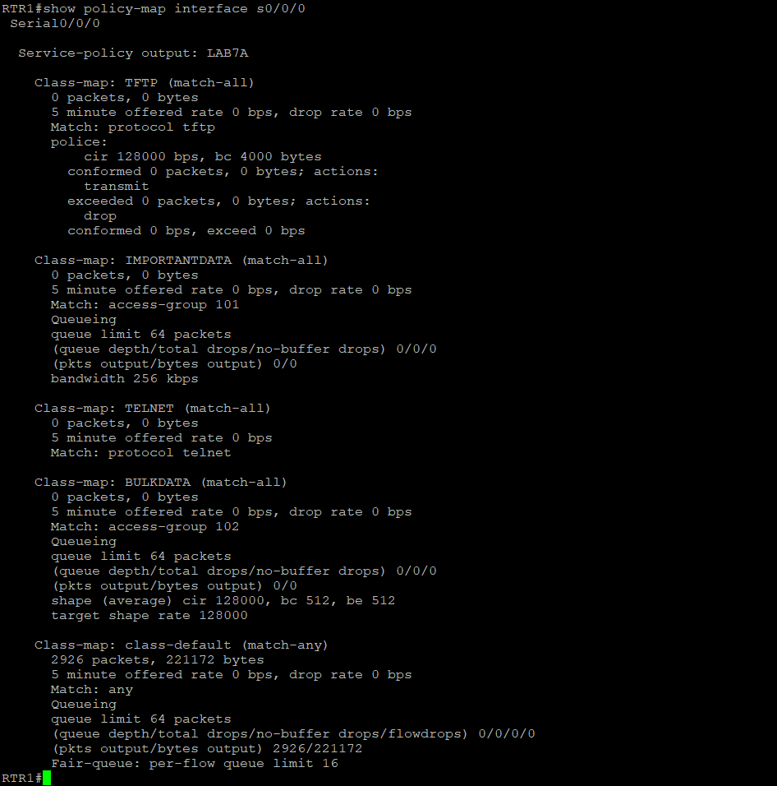
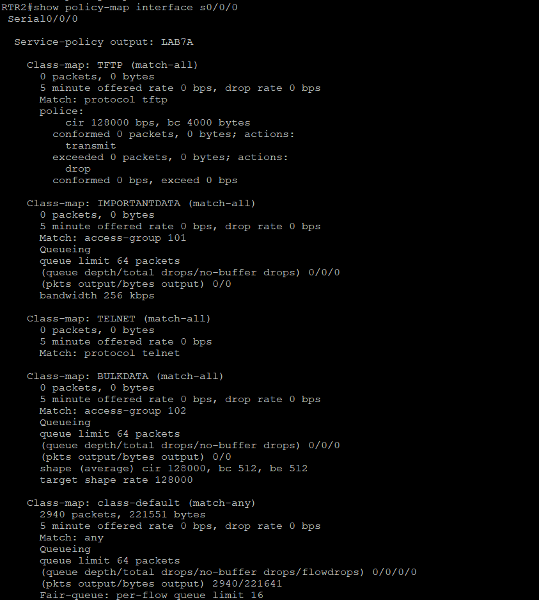

End of Lab Questions:

1. What is the purpose of class maps in QoS configuration?
Class maps are part of QoS configuration for classification of traffic into different categories.

2. How does the `police` command differ from the `shape` command in QoS configuration?
Police forces traffic rate limits and drops excess traffic. While shape smooths traffic to a specified rate without dropping excess.

3. What is the function of the `priority` keyword in a policy map?
The priority keyword ensures that traffic in the defined class is considered high priority and low delay. This is usually used for latency sensitive traffic like voice traffic.

4. Why is it important to apply a service policy to an interface?
Applying a service policy to an interface is important to force QoS settings. For example, defining priority, shaping or policy on the traffic going through that interface.

When finished, please submit as yourname_Lab7a.doc

